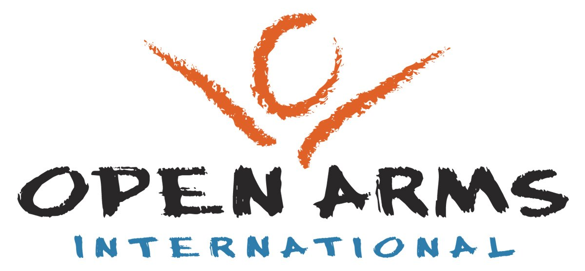
Outreach Opportunities in Kenya
Open Arms International seeks to combine medical care and Christian ministry into a powerful combination that can deliver God’s healing touch.
Would you like to be part of that vision?

Would you like to spend 2 weeks in Eldoret, Kenya, working amongst the poor and marginalised?
Are you interested in medical / dental clinics, children’s ministry, prison ministry, building work, church leadership training?

Then an Open Arms outreach trip could be just what you are looking for!
Dates of forthcoming trips (2008)  June 14 – 28  July 12 – 26  July 26 – Aug 10  September 13 -27  September 27 – October 10  November 1 - 16 |  |  | For more information contact Helen Harrison  07966 034584  helen@openarms.org.uk  or visit the website  www.OpenArmsInternational.org.uk

Open Arms International, PO Box 144, Stockport, SK7 6WG, Charity No.:1095664

