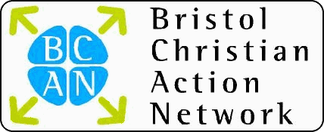

in association with

ENGAGING WITH THE COMMUNITY
through Family Ministry
Richard Hardy (Care for the Family)
Thursday 3rd May 2007
12:30 – 2:30pm
Venue: Woodlands Christian Centre, Belgrave Rd, Clifton, Bristol, BS8 2AA
(On street parking is limited but there is an carpark off Whiteladies Road near Sainsburys)

We all know that a gap has opened up between church and community the question and challenge for all of us, including church leaders and community workers, is “How do we bridge the gap and make connections that will lead to community transformation?”

In this session Richard Hardy, Church and Community Development Manager for Care for the Family, and a church leader for over 25 years, will talk about why we should connect with community through issues of family and how we can take practical steps to see the needs of families met and their dreams realised.
Bring your own lunch / drinks are provided.
For further information: T: 0117 9557430; E: admin@bcan.org.uk

